**876-665-3916**

Caribbean Polytechnic Institute

Caribbean Polytechnic Institute



**BIG**

**100%**

**Free**

**Membership**

A close up of a map

Description generated with high confidenceA picture containing room, scene, gambling house

Description generated with very high confidence





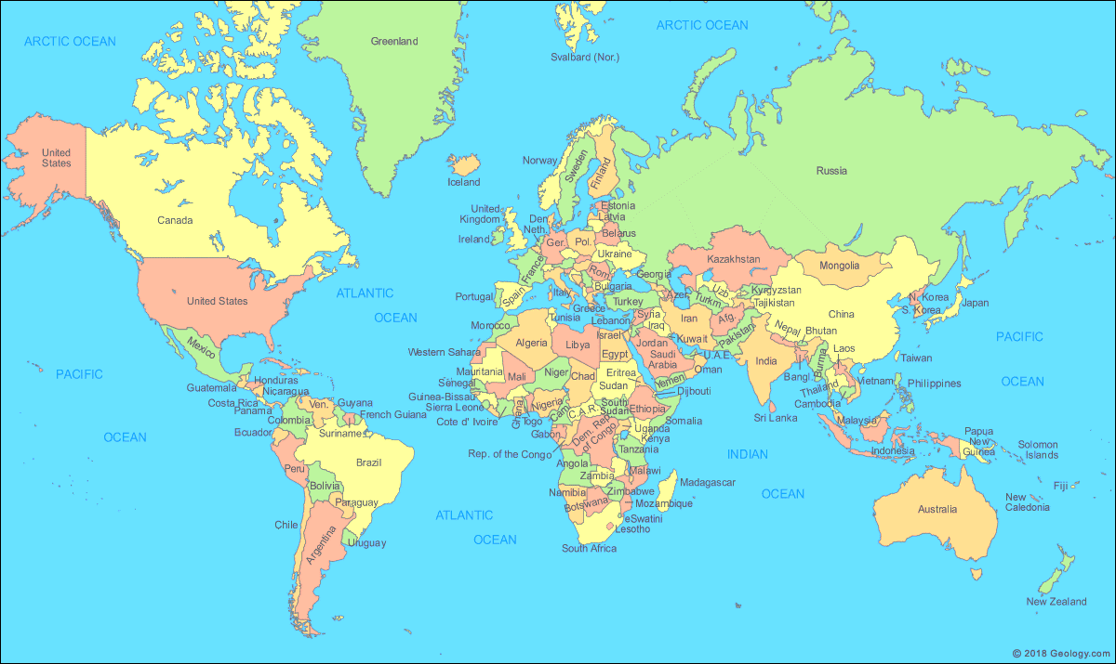

**Certified Global Business Professional (CGBP)**

*A world of learning at your fingertips*



**Global Business**



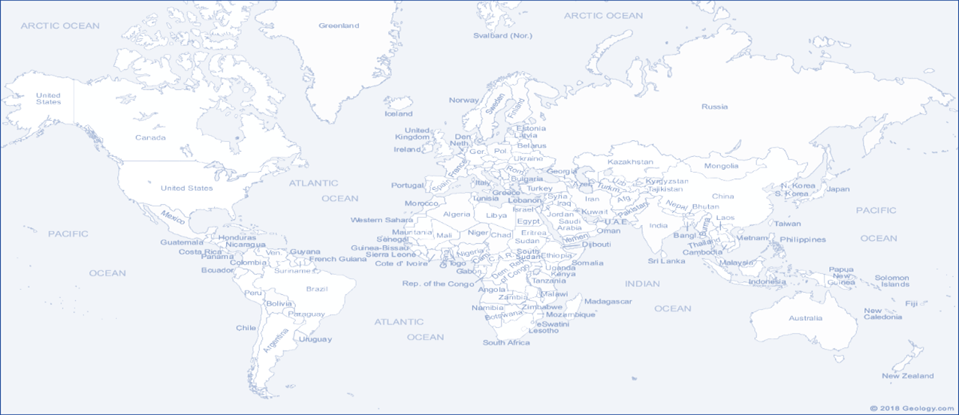

**Online Campus**

*a world of learning at your fingertips*