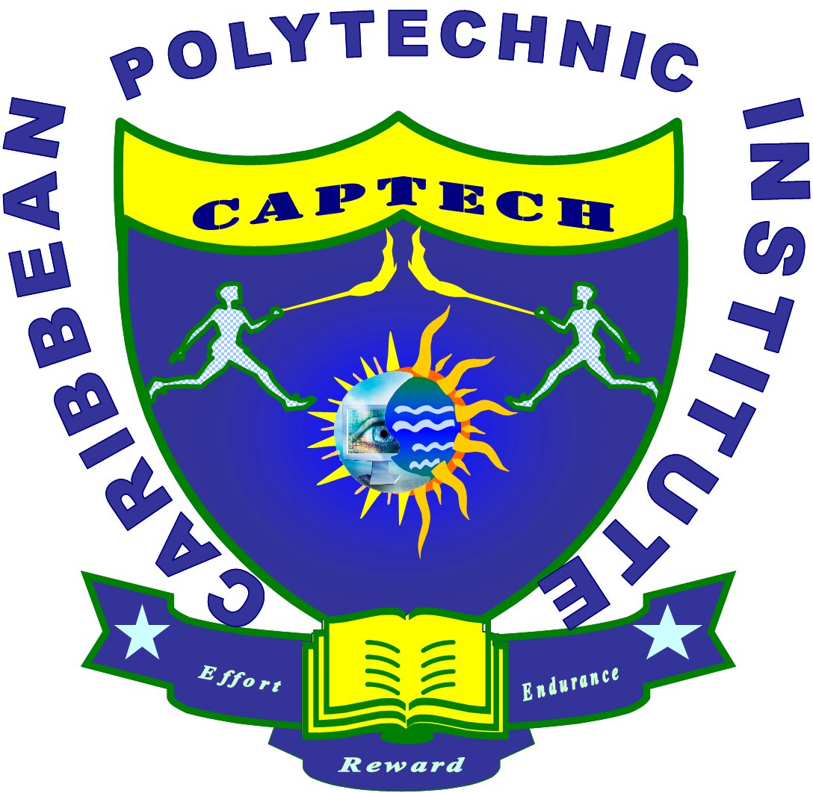

CARIBBEAN POLYTECHNIC INSTITUTE

Registration Form

From the list of courses below, place a tick to the left of the one for which you will be registering:

- Building Infrastructure and Utilities Maintenance
- Public Relations
- Level 4 Diploma Learning and Development
- Instructional Design
- Contract Administration
- Environmental Management System
- Food Safety Principles and Practices
- Horticulture and Landscape Maintenance
- Consultancy Skills Training
- Project Management (PMP)
- Project Management (CAPM)
- Professional in Human Resource (PHR)
- Senior Professional in Human Resource (PHR)
- Project Management Concept and Strategies
- Manager of Quality and Organisational Change
- Purchasing
- Strategic Management
- Logistics
- Facility Management
- Supply Chain Management
- Quality Assurance Management
- Supervisory Management
- Urban Integrated Pest Management
- Other_______________________

Name of Participant ___________________ Date of Birth___________

Mailing Address __________________________________________

Telephone No: __________________________________________

Education: Secondary Tertiary  Other _________________

Summary of Qualifications
______________________________________________________________________________________________________________________________________________________________________________________________________________________________________________________________________________________________________________________________________________________________________________________________________

Company Name __________________________________________

Job Title __________________________________________

Years of Experience in Related Activities_________________________________

Student Signature: ____________________________

Date: ____________________________

